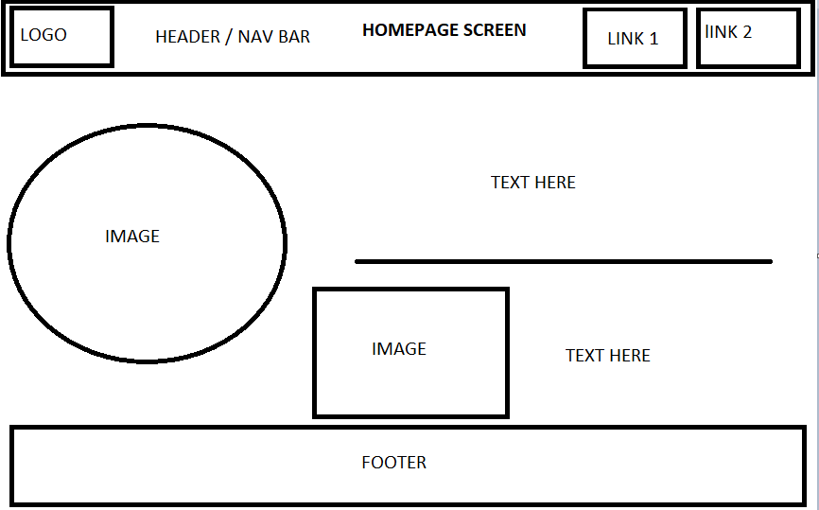

Login page

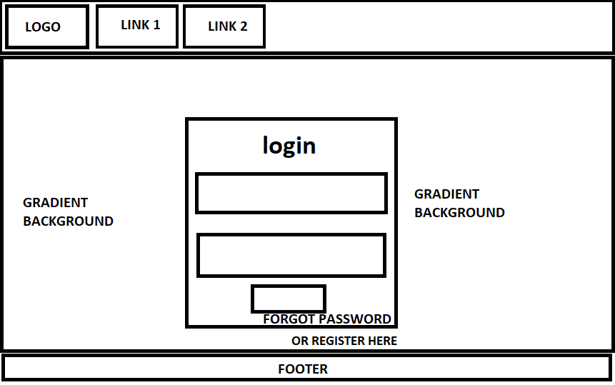

REGISTER FORM

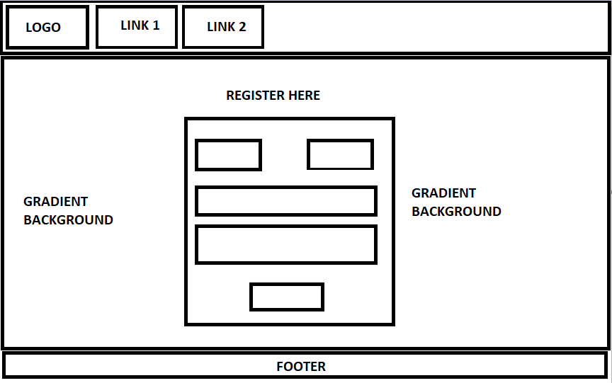

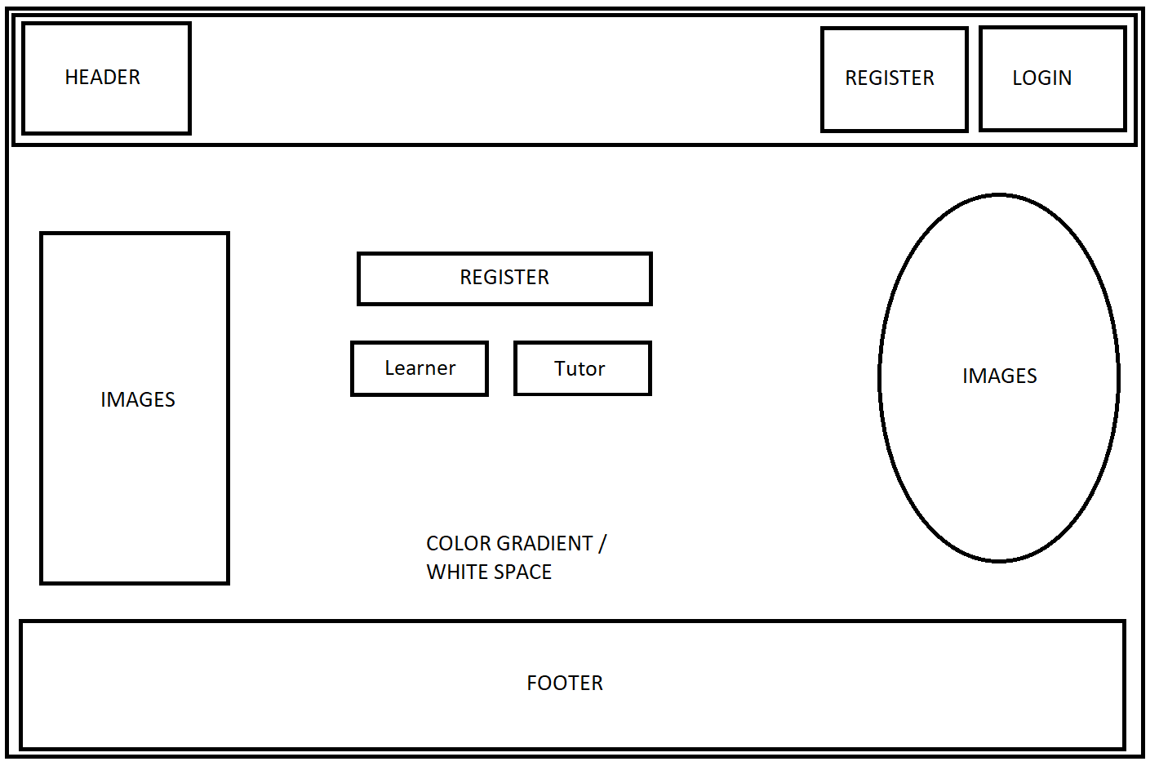

* Enables teachers to monitor learner progress.
* Increases learners' engagement and interaction.
* Provides informative feedback for both learner and tutor on learners progress.
* Tutors can set goals and progress points based off of assessment results.
* Less time wasted working out what point the learner is at with the module or unit.

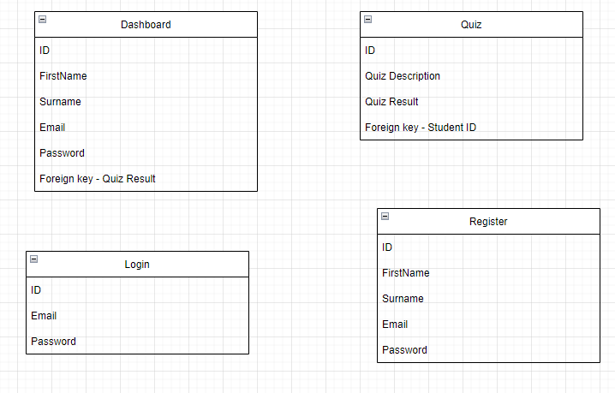

SITE MAP

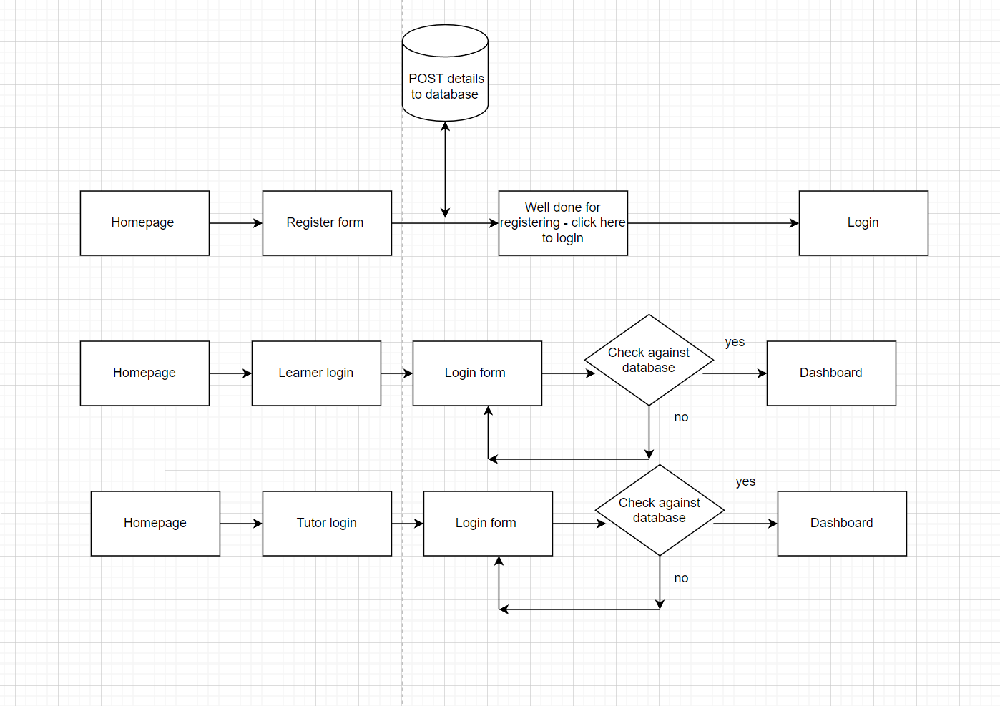

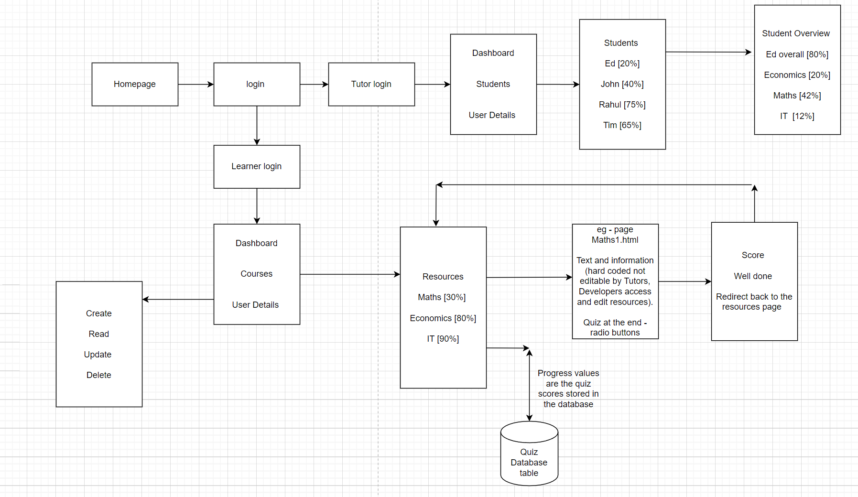

**KPIS**

* Must be compatible with smartphones, tablets, laptops and desktops. All accessible internet devices.
* Must allow users to take assessments and have their progress/score recorded.
* Must have functionality where both learner and tutor can see the learners progress.
* Maintain a suitable speed for each user
* Maintain a good general capacity (storage, processing power, etc.) - don’t overload.]

**Data**

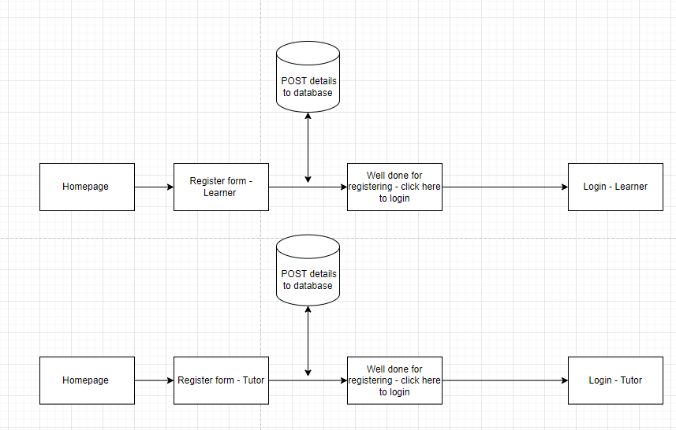

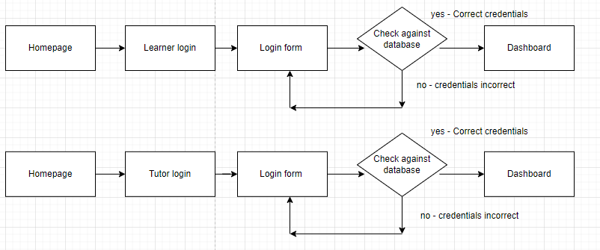

This shows that I will have a learner and tutor register and login system. This will produce 4 tables in the database, and only learners can login via the learner form and vice versa for the tutors.

The login system tests against the register database and once logged in a session will start and the login table learner/tutor will be filled in until that session runs out and then data will be removed from the table.

**Front end requirements and needs.**

There is a need for:

* An attractive and well laid out interface throughout the website.
* Link to back end

**Backend requirements and needs**

Data storage

Ability to read and write data

Security

Link to front end

[https://online.visual-pahttps://online.visual-paradigm.com/app/diagrams/#diagram:proj=0&type=DataFlowDiagram&width=11&height=8.5&unit=inchradigm.com/app/diagrams/#diagram:proj=0&type=DataFlowDiagram&width=11&height=8.5&unit=inch](https://online.visual-paradigm.com/app/diagrams/#diagram:proj=0&type=DataFlowDiagram&width=11&height=8.5&unit=inch) FOR DFD Diagrams

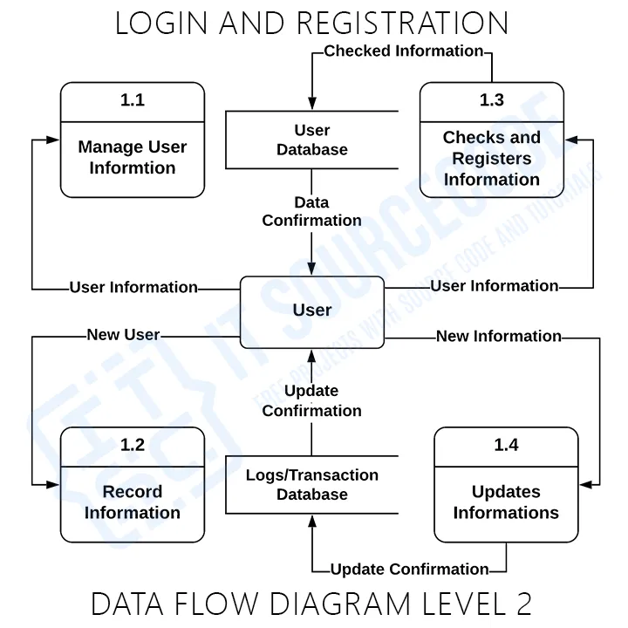

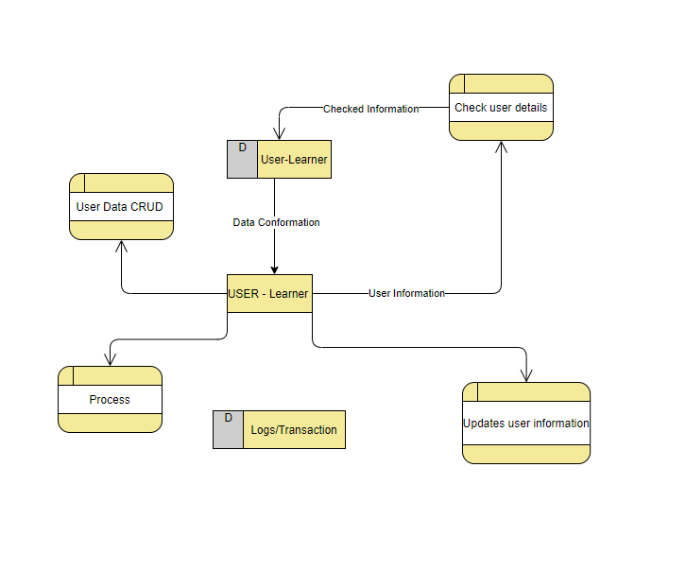

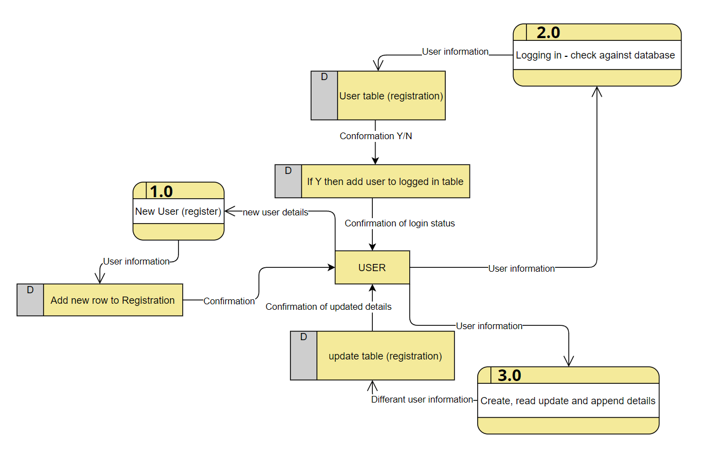

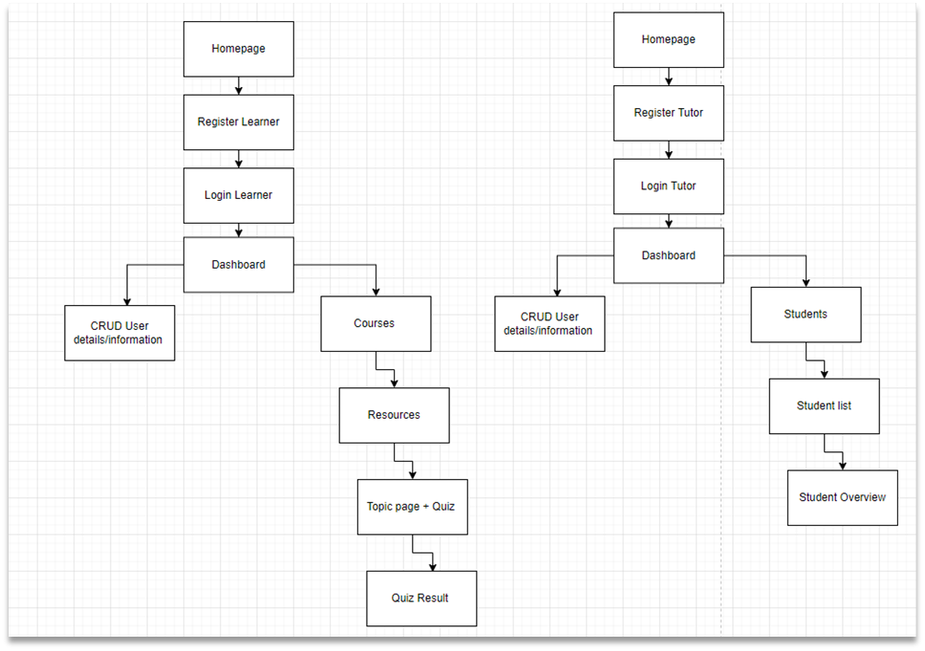

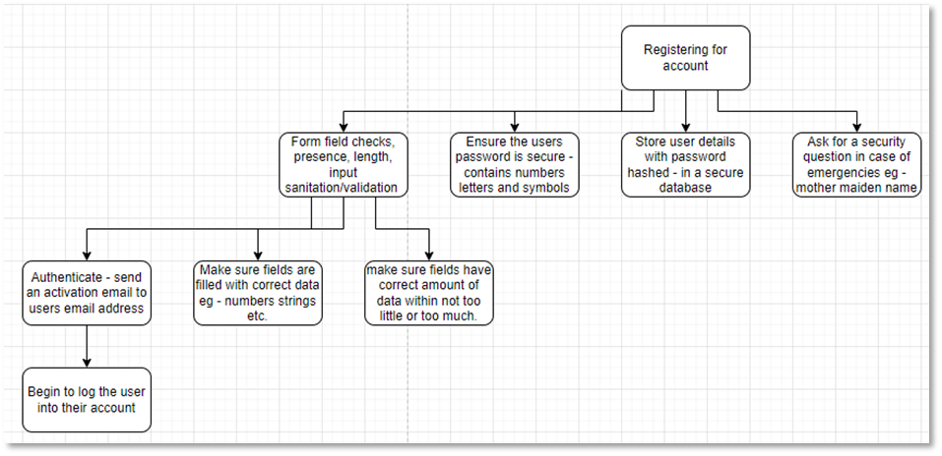

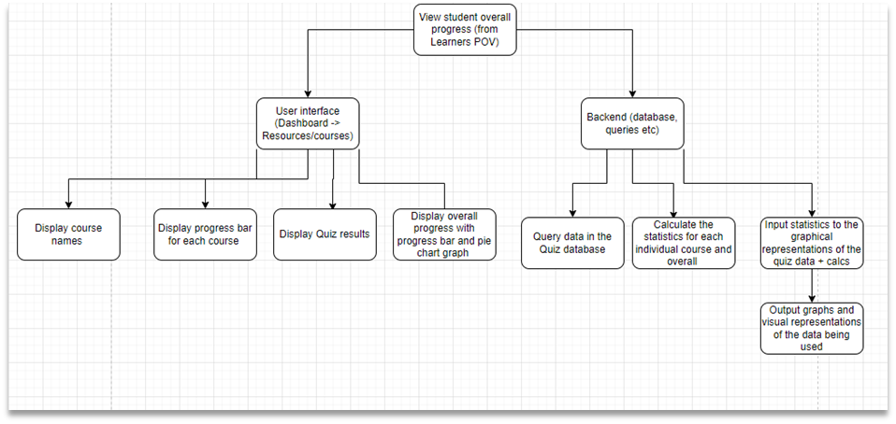

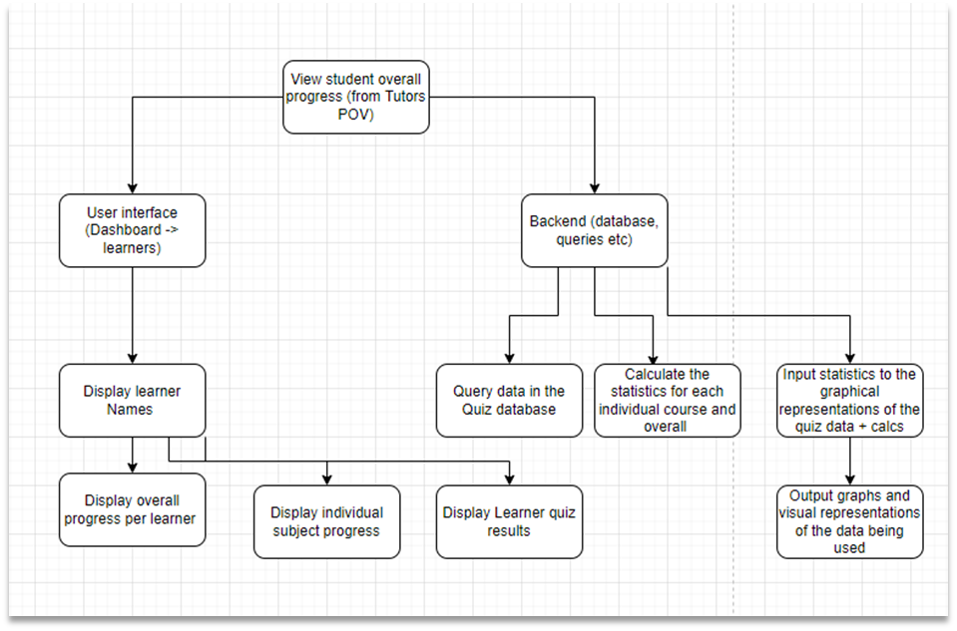

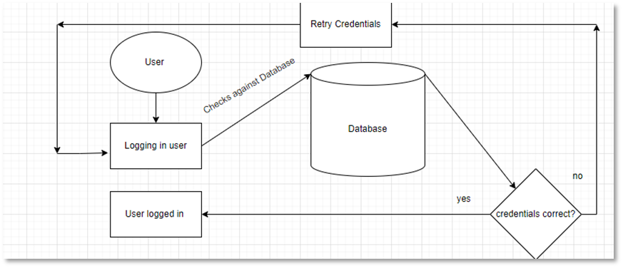

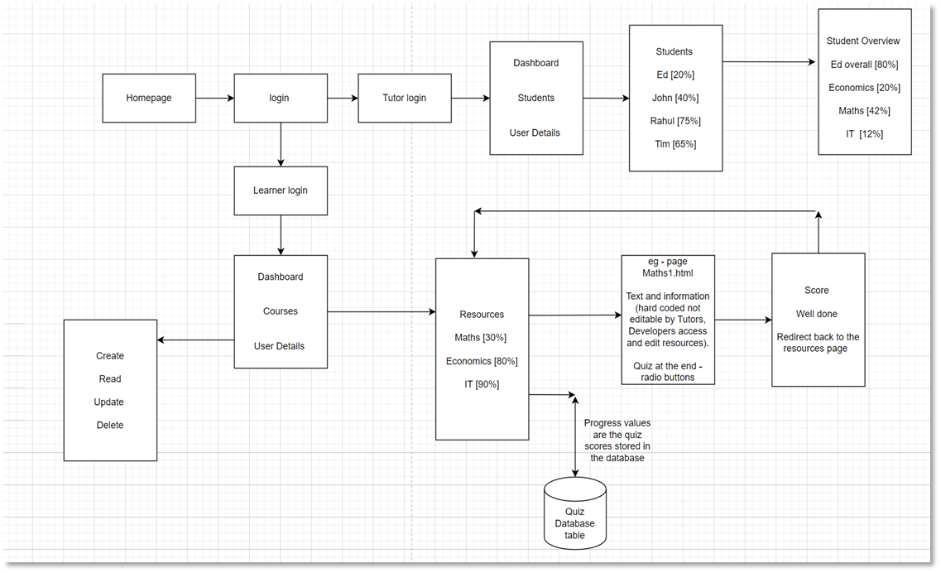

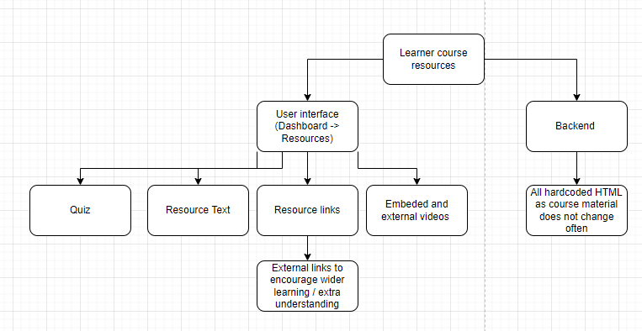

My proposed solution should provide GibJohn Tutoring with a digital solution that will add on to their current web application. My digital solution will include features such as more interactive questions, continuous progression monitoring, assessment, and links to encourage a wider learning.

**Stakeholders + UI and UX**

I have researched on 2 websites Mathswatch and Khan Academy in Task A(i) and evaluated the quality of user interface and experience implemented on those websites. To see this check Task A(i) in the appendices. This links to Schnidermans 8 golden rules and Nielsen's 10 heuristics. The references table is available in my appendices.

The stakeholders of GibJohn requested that the digital solutions interface was as simplistic, clear and easily readable. The general consensus was to keep color/contrast schemes for the digital solution basic yet aesthetically pleasing for users throughout the entirety of the system. There were also requests for plenty of whitespace to make important interface aspects more noticeable and give the user an experience of a well laid out interface that is not crammed with numerous blocks of text or images (quality over quantity). There was also mention of keeping things like headers, navigation bars and footers the same across the entirety of the solution. In order to achieve this I'm going to implement templating (with Blade) which will include the same digital layout with content being the only changing thing between different pages. Error messages and issues that the digital solution may produce will need to have a clear description letting the user know how they can rectify the issue - always keep the user informed of the current system status. This links in with the target audience between the ages of 4 - 18 (in education) however there are also going to be Tutors, possibly parents and the exam boards using GibJohn Tutoring so this presents a huge range of users. So in order to accommodate such a range, like I said above, I will be going for a simplistic and yet aesthetically pleasing interface design. I will be using text and fonts that are universal and readable. I will keep in mind that there will be younger ages interacting with the website at times and things need to be coloured/named/laid out in ways in which they can understand.

Learners:

* Register for account and login
* View dashboard
* Edit user information
* View courses
* View individual courses and unit progress (graphical and statistical)
* Read through course content
* Complete quizzes

Tutors:

* Register for account and login
* View individual dashboard
* View and monitor students
* View and monitor individual students and their progress both graphically and statistically.
* ############ **Possibly assign specific students to courses.**

The user of GibJohn tutoring will be presented with a dashboard and depending on their user access level, they will have different specialist options for instance - Tutor (list of learners). However all users on their dashboard will have a section in which they can CRUD (Jayaram and &rarr;, 2022) their user details. GibJohn will be following up-to-date legislations and data protection acts (Data protection GDPR, 2022) to keep in line with the law and keep out of financial, legal, and reputation action. It also ensures user details confidentiality and puts users at ease knowing their data is secure. To provide this I will be hashing passwords once entered into the credential forms, and ufusing an php function mysql real escape string which stops sql commands being sent to the database via the form fields.

<https://css-tricks.com/the-many-ways-of-getting-data-into-charts/> - could have a table of students with progress bars and on click of one of the students it then goes into a dashboard with a vertical barchart of the students progress in different areas.

| Style | In-text citation | Reference list |
| --- | --- | --- |
| Harvard | (Jayaram and &rarr;, 2022)  Or  CRUD (Jayaram and &rarr;, 2022) | Jayaram, P. and &rarr;, V., 2022. *CRUD operations in SQL Server*. [online] SQL Shack - articles about database auditing, server performance, data recovery, and more. Available at: <https://www.sqlshack.com/crud-operations-in-sql-server/> [Accessed 16 February 2022]. |
| Harvard | (Data protection GDPR, 2022) | GOV.UK. 2022. *Data protection*. [online] Available at: <https://www.gov.uk/data-protection> [Accessed 16 February 2022]. |

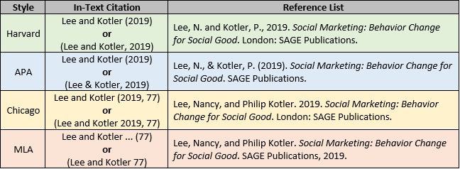

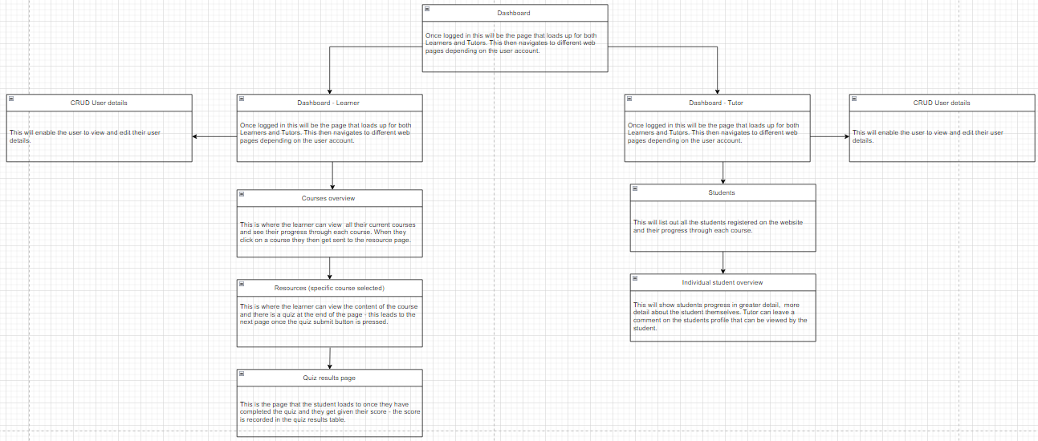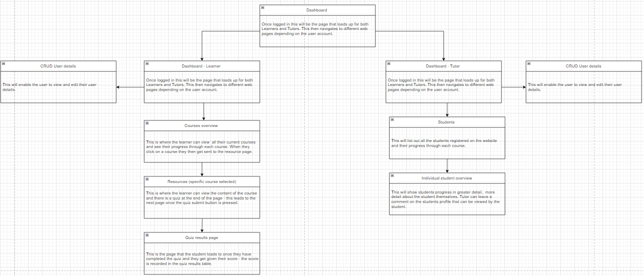

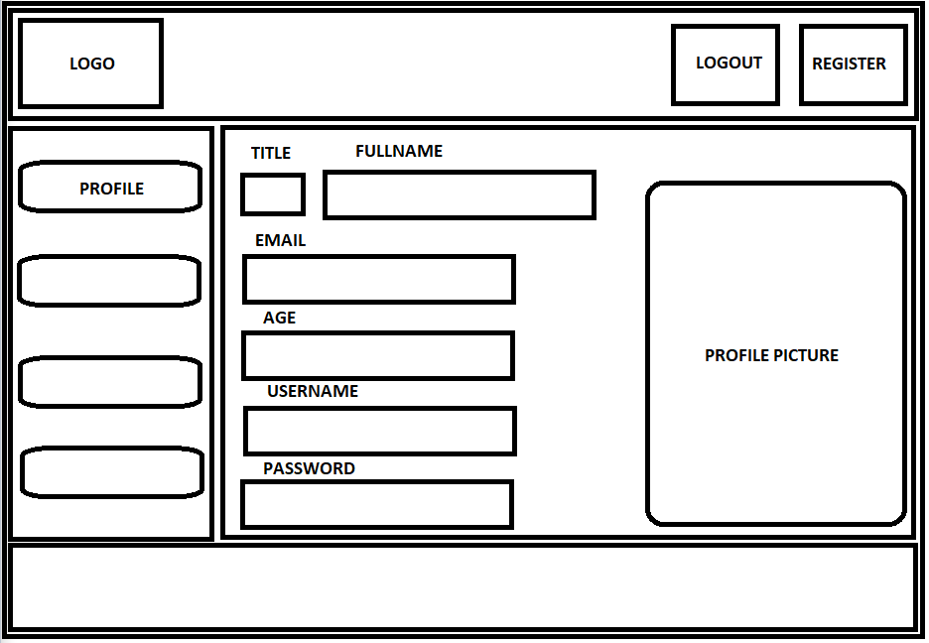

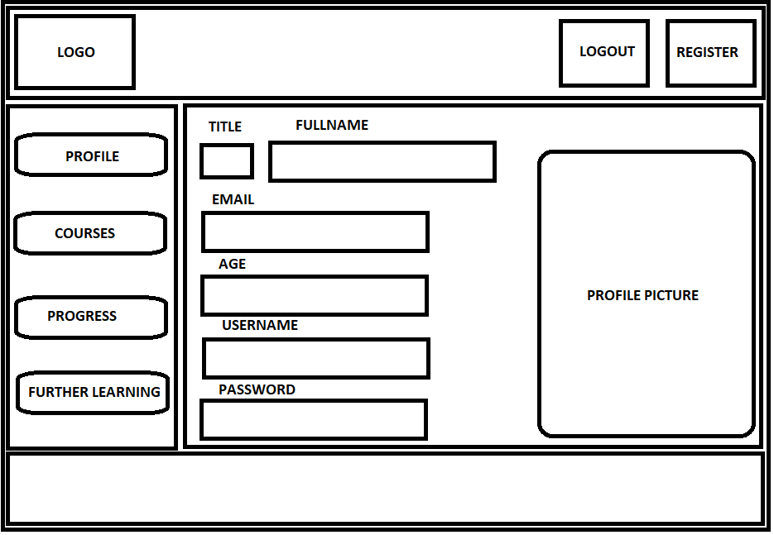

DASHBOARD LEARNER

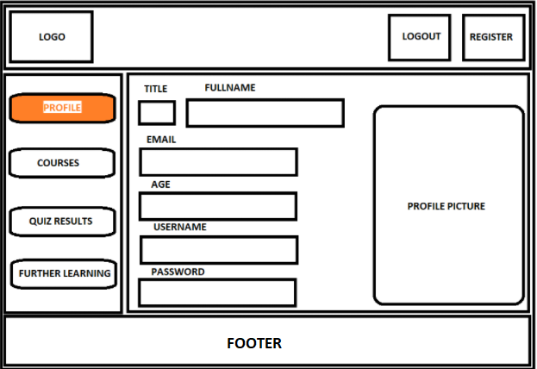

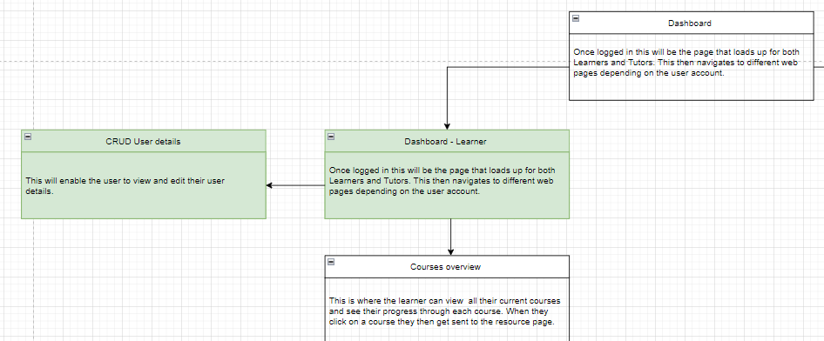

DASHBOARD TUTOR

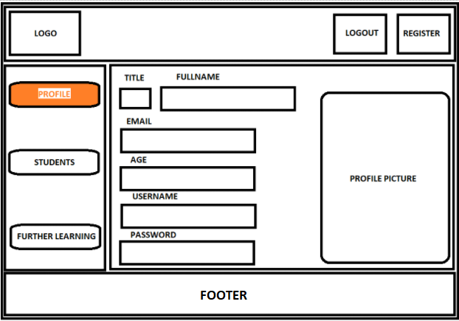

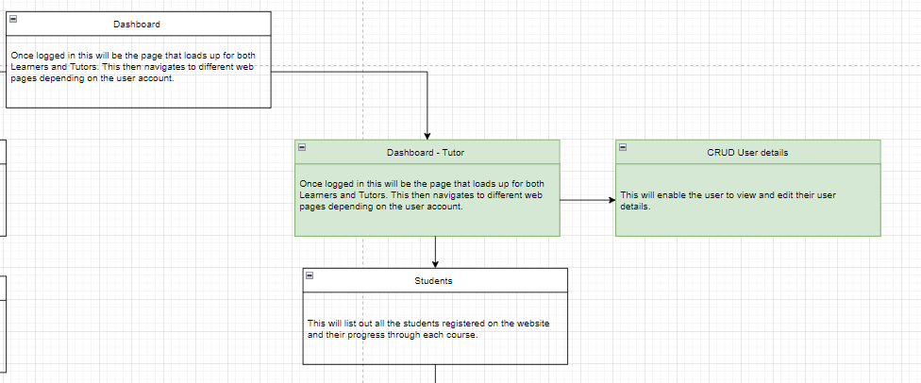

COURSE LEARNER

